

NLC INDIA LIMITED – NEYVELI
“NAVRATNA - A GOVERNMENT OF INDIA ENTERPRISE”

INTERNSHIP REPORT ON

A TRAVEL/TOURISUM WEBSITE BASED ON WEB DESIGN

SUBMITTED BY

S.S.TEJASWINY

B.E., COMPUTER SCIENCE AND ENGINEERING



MRK INSTITUTE OF TECHNOLOGY
(An Autonomous Institution, Affiliated to Anna University, Chennai)
Kattumannarkoil – 608 301, Tamil Nadu.

UNDER THE GUIDANCE OF

Smt.ALAMELU.V,
CHIEF MANAGER / COMPUTER SERVICES, TA OFFICE, NLCIL.,NEYVELI.


NLC INDIA LIMITED – NEYVELI
(“NAVRATNA”- A GOVERNMENT OF INDIA ENTERPRISE”)

NEYVELI-607 801, TAMIL NADU

BONAFIDE CERTIFICATE

Certified that the Internship Training report titled “A TRAVEL/TOURISUM WEBSITE BASED ON WEB DESIGN” is the bonafide work of,
S.S.TEJASWINY

Studying B.E., COMPUTER SCIENCE AND ENGINEERING at
“MRK INSTITUTE OF TECHNOLOGY”, Kattumanarkoil done during the period from 07-07-2025 to 26-07-2025 at TA, NLC INDIA LIMITED, NEYVELI.

Her performance, conduct and attendance during the period was found to be _______________

SIGNATURE OF THE GUIDE
DATE: 26-07-2025 CHIEF MANAGER/COMPUTER SERVICES/TA
PLACE: NEYVELI NLC INDIA LIMITED

Permitted to submit the internship report to college / university authority

DATE: 26-07-2025 GENERAL MANAGER
PLACE: NEYVELI LEARNING AND DEVELOPMENT CENTRE
NLC INDIA LIMITED

DECLARATION

We hereby declare that the Internship training report titled “A TRAVEL/TOURISUM WEBSITE BASED ON WEB DESIGN” is the original work done by us under the guidance of Smt.ALAMELU, CHIEF MANAGER/ COMPUTER SERVICES, TA OFFICE, NLC INDIA LIMITED, NEYVELI.
This internship report is for reference only and no part of the report will be published/copied anywhere without the written permission from officials of NLCIL, NEYVELI.

SIGNATURE OF THE STUDENT
S.S.TEJASWINY

ACKNOWLEDGEMENT

I express my sincere thanks to NLC INDIA LIMITED for providing me the opportunity to carry out the Internship Training.

I also express my sincere thanks to SHRI. A.Kr. SARAVANABHAVAN, General Manager / Unit Head/L&DC, SHRI. PRABAKARAN K, Deputy General Manager / L&DC and the Executives & the staffs of Learning and development center for providing me the opportunity to carry out the Internship Training in NLC INDIA LIMITED, NEYVELI.

I express my gratitude to SHRI.VAITHIYANATHAN, GENERAL MANAGER, TA OFFICE, NLC INDIA LIMITED for granting me permission to undergo internship training program from 07-07-2025 to 26-07-2025

I would also express my sincere gratitude towards thank Smt.ALAMELU.V, CHIEF MANAGER/ COMPUTER SERVICES, TA OFFICE, NLC INDIA LIMITED for providing the guidance and support for the Internship.

I sincerely thank Dr. K. ANANDAVELU, Principal / MRK INSTITUTE OF TECHNOLOGY for providing me support and guidance for the Internship.

I extend my Profound thanks to Mrs. N. HEMALATHA, HOD / CSE Dept./ MRK INSTITUTE OF TECHNOLOGY for encouraging me to successfully complete the Internship Training.

INDEX

CHAPTER  NO | CONTENT | PAGE NO
I | INTRODUCTION:  - ABOUT NLC INDIA LIMITED  - ABOUT CONCERN UNIT | 6  8
II | CONTENT OF THE STUDY:  - HTML  - CSS  - JavaScript  - MongoDB  - Node.js  - Visual Studio Code  PROJECT CODE / OUTPUT: | 12  13  13  14  15  15  (17 - 59)
III | CONCLUSION  REFERENCE  FEEDBACK | 60  61  62

INTRODUCTION

NLC INDIA LIMITED:

NLC India Limited (NLC), formerly known as Neyveli Lignite Corporation India Limited, is a central public sector undertaking under the administrative control of the Ministry of Coal, Government of India. Established in 1956, NLC is headquartered in Neyveli, Cuddalore district, Tamil Nadu. It is a prominent Navratna company, engaged extensively in the mining of lignite and coal, as well as the generation of power using lignite, coal, solar, and wind energy sources.

KEY HIGHLIGHTS:
- Mining Operations:
  - NLC operates opencast lignite mines at Neyveli in Tamil Nadu and Barsingsar in Rajasthan, with an annual production of around 30 million tonnes of lignite.
- Power Generation:
  - It runs six lignite-based thermal power stations with a total capacity of 3640 MW, and through joint ventures and subsidiaries, also operates coal-fired plants (notably a 1000 MW thermal power plant with TANGEDCO at Thoothukudi, Tamil Nadu).
  - NLC sells electricity primarily to state electricity distribution companies (DISCOMS) in southern India and Rajasthan.
- Renewable Energy:
  - The company has diversified into the renewable energy sector, commissioning 1404 MW of solar power capacity and 51 MW from wind farms.
  - Several new solar projects totaling over 1200 MW are under development in Tamil Nadu.
- Expansion Plans:
  - NLC aims to become a 20,000+ MW company by 2025, with new plants under construction and a pipeline of thermal and renewable projects.
  - It is developing a major coal-based thermal power plant (3x660 MW) in Uttar Pradesh via joint venture with UPRVUNL.
- Geographical Footprint:
  - Besides Neyveli and Barsingsar, NLC’s operations or interests extend to Puducherry, the Andaman & Nicobar Islands, and multiple liaison offices in major cities such as Chennai, Hyderabad, Mumbai, Kolkata, Bhubaneswar, and New Delhi.
- Corporate Profile:
  - NLC was wholly owned by the Government of India but is now partly held publicly, with shares traded on Indian stock exchanges.
HISTORICAL SIGNIFICANCE:
- The discovery of lignite in Neyveli traces back to 1934, with industrial development launching in the 1950s after detailed geological surveys.
- NLC was formally incorporated in 1956, and its launch was inaugurated by then Prime Minister Jawaharlal Nehru.
- It has played a significant role in industrializing the region and contributing to the national energy supply for near 70 years.
SOCIAL AND ECONOMIC CONTRIBUTIONS:
- Beyond its industrial mandate, NLC has contributed to regional socio-economic development, including infrastructure, healthcare, and education in its operational regions.

COMPANY PROFILE
TOWNSHIP ADMINISTRATION
OVERVIEW:
The Township Administration Department at NLC India Limited (NLCIL) is responsible for managing the Neyveli Township and associated residential, infrastructural, and welfare amenities for employees and their families. This township, established to support the workforce of NLC, plays a vital role in maintaining a high standard of living and a holistic work-life environment for residents.
KEY FEATURES OF TOWNSHIP ADMINISTRATION:
STRUCTURE AND ORGANIZATION:
- Departmental Oversight: The Township Administration operates under NLCIL with an office located at Block-10 in Neyveli Township, Cuddalore district, Tamil Nadu.
- Administrative Division: The township has been divided into 30 blocks, each managed for optimal facilities and services.
- Supervision: Senior administrative officers and advisors oversee township management, ensuring smooth coordination of civic services.
FACILITIES AND SERVICES
- Housing: Provision of residential quarters for employees, supervisors, and officers, including maintenance and allocation.
- Civic Maintenance: Supply of water, sanitation, electricity, and road infrastructure throughout the township.
- Recreation and Welfare: Facilities include parks, sports complexes, libraries, community centers, and clubs for recreational activities.
- Healthcare: Medical facilities such as hospitals and health centers, ensuring accessible healthcare for all residents.
- Education: Schools and educational institutions within the township serve employees' children and the local community.
- Transport: Arrangements for efficient internal transportation within the township for work and daily commuting.
- Security: The administration monitors security and safety through its own mechanisms in coordination with local law enforcement.
EMPLOYEE WELFARE
- NLCIL's township administration is well-recognized for establishing a healthy working and living environment, including welfare programs, crèches for children, and vocational training.
- Services extend to both intramural (housing, recreation, health) and extramural (education, external amenities) welfare schemes.
SOCIO-ECONOMIC CONTRIBUTION
- The township not only benefits NLC staff but also contributes to the overall socio-economic development of the Neyveli region by providing public infrastructure and community support facilities.
- The holistic development model adopted by NLCIL’s township sets a benchmark among public sector undertakings in India.
CONTACT AND GOVERNANCE
- Head Office: Block-1, Neyveli Township, Cuddalore District, Tamil Nadu - 607801.
- Township Office: Block-10, Neyveli Township.
Summary Table: Major Services Managed by Township Administration
Service Area | Description
Housing | Staff quarters, maintenance, allocation
Health | Hospitals, clinics, & health centres
Education | Schools, training institutes
Recreation | Parks, clubs, libraries, sports infrastructure
Civic Amenities | Roads, water supply, sanitation, street lighting
Security | Surveillance, coordination with law enforcement
Transport | Internal employee transportation
NLC India's township administration stands out as a model of employee welfare and urban civic management within India's public sector.

COMPUTER SERVICES
OVERVIEW:
The Computer Services Department at NLC India Limited (NLCIL) is a specialized department dedicated to managing the organization's information technology (IT), digital infrastructure, and Enterprise Resource Planning (ERP) systems. It plays a critical role in ensuring robust IT-enabled services throughout the company’s extensive operations.
KEY FUNCTIONS
- IT Infrastructure Management:
Oversees the procurement, maintenance, and upgrading of all IT hardware—personal computers, servers, workstations, and peripherals—across NLCIL’s offices and industrial sites.
- Enterprise Resource Planning (ERP):
Manages the implementation and operation of ERP solutions to integrate and automate business processes such as procurement, finance, HR, and project management.
- Support & Maintenance:
Provides ongoing technical support, troubleshooting, and maintenance for IT assets to ensure minimal downtime and high productivity. This includes biennial maintenance contracts for computers and related equipment.
- Cybersecurity:
Oversees data protection, including implementing security protocols, firewalls, and regular security audits, ensuring the safety of digital assets and critical operational information.
- Software & Applications:
Facilitates the deployment, licensing, and upkeep of software applications used for core business functions, engineering, analytics, and administration.
- Data Management:
Maintains data centres, robust networks, and storage solutions to support smooth business operations, record-keeping, and regulatory compliance.
ORGANIZATIONAL STRUCTURE
- The department is headed by the Chief General Manager, Computer Services & ERP, operating from the NLCIL Corporate Office at Block-1, Neyveli, Tamil Nadu.
TECHNOLOGY INITIATIVES
- Digital Transformation:
The department leads the drive toward digitalization, expanding IT-enabled services and automation within the company.
- E-tendering and E-Procurement:
Manages and supports online procurement platforms enabling transparent, paperless purchase and bidding processes across the company.
- Business Continuity & Disaster Recovery:
Implements policies and best practices to maintain continuity of IT services during power interruptions, cyber-attacks, or hardware failures.

CONTENT OF STUDY
INTRODUCTION
This report provides an in-depth overview of essential web development technologies: HTML, CSS, JavaScript, MongoDB, Node.js, and the Visual Studio Code (VS Code) editor. It outlines their purpose, features, integration points, and best practices, giving a holistic understanding for students and professionals aiming to develop modern web applications.
1. HTML (Hypertext Markup Language)
Purpose
- Serves as the foundational markup language for structuring web pages and applications.
Key Concepts
- Elements & Tags: <html>, <head>, <body>, <div>, <a>, <img>, etc.
- Attributes: Define element properties (e.g., src, href, alt).
- Semantics: Use of tags for meaning—<header>, <footer>, <nav>, <article>, <section>.
- Forms: Input fields, buttons, validation attributes for user data collection.
Sample Structure
<!DOCTYPE html>
<html lang="en">
<head>
<meta charset="UTF-8">
<title>Sample Webpage</title>
</head>
<body>
<h1>Welcome!</h1>
<p>This is a simple HTML page.</p>
</body>
</html>
2. CSS (Cascading Style Sheets)
Purpose
- Adds styling and layout to HTML elements, separating content from presentation.
Key Concepts
- Selectors & Properties: Target elements to apply styles (color, background, font-size).
- Box Model: Arrangement—margin, border, padding, content.
- Responsive Design: Media queries for device adaptability.
- Flexbox & Grid: Modern layout techniques for flexible, responsive designs.
Sample Style
body {
background-color: #fafafa;
font-family: Arial, sans-serif;
}
h1 {
color: #008080;
text-align: center;
}

3. JavaScript
Purpose
- Provides interactivity, logic, and dynamic content on web pages.
Key Concepts
- Variables, Data Types, Functions: Foundation for scripting.
- DOM Manipulation: Interact with and modify page structure/content.
- Event Handling: onclick, onchange, etc.
- ES6+ Features: let/const, arrow functions, modules, async/await.
- AJAX, Fetch API: Background data exchange for seamless updates.
Example
document.getElementById("myBtn").addEventListener("click", function() {
alert("Button clicked!");
});

4. MongoDB
Purpose
- NoSQL document-oriented database—stores data in flexible, JSON-like documents.
Key Concepts
- Collections & Documents: Analogous to tables and rows in SQL.
- Schema-less: Structure can evolve per document.
- CRUD Operations: Create, Read, Update, Delete.
- Indexing: Enhances search/query performance.
- Aggregation Framework: For data analysis and transformation.
Example Document
{
"name": "Alice",
"email": "alice@example.com",
"age": 28
}
Key Benefits
- Scalability (horizontal, sharding)
- High availability via replication

5. Node.js
Purpose
- JavaScript runtime environment on the server; enables backend logic and APIs using JavaScript.
Key Concepts
- Event-driven, Non-blocking I/O: Efficient for real-time, scalable applications.
- Modules: Built-in (fs, http) and external (via npm).
- Express.js: Popular framework for building RESTful APIs.
- Middleware: Functions executed during request handling.
Example HTTP Server
const http = require('http');
http.createServer((req, res) => {
res.write('Hello, World!');
res.end();
}).listen(3000);

6. Visual Studio Code
Purpose
- Free, cross-platform source code editor from Microsoft, widely used for web development.
Key Features
- Syntax Highlighting & Intellisense: For faster, error-free coding.
- Extensions Marketplace: Vast array of tools (e.g., ESLint, Prettier, Git integration).
- Integrated Terminal: Run shell commands, Node.js, npm scripts.
- Debugging Tools: Breakpoints, watch expressions, call stacks.
- Version Control: Built-in Git UI for code management.

Best Practices
- Organize code using multiple workspaces and folders.
- Use the settings and extensions to customize environment for target tech stack.
7. Building a Modern Web Application: Integration Workflow
- Design UI: Structure content with HTML, style with CSS, and add interactivity via JavaScript.
- Backend Logic: Use Node.js (often with Express.js) to build API endpoints.
- Database Integration: Store and retrieve data from MongoDB.
- Development Tools: Use Visual Studio Code for efficient writing, debugging, and collaboration.
- Full Stack Example:
  - Frontend: HTML/CSS/JS fetches and displays data.
  - Backend (Node.js/Express): Receives HTTP requests, queries MongoDB, sends JSON responses.
  - Database: MongoDB stores application data (e.g., users, posts, items).
8. Sample Project Structure
Folder/File | Description
/public | Frontend assets (HTML, CSS, JS, images)
/src | Backend source (Node.js, Express routes)
/models | MongoDB schemas (Mongoose models)
server.js | Node.js/Express app entry point
package.json | Project metadata, scripts, dependencies
.vscode/ | VS Code settings, launch configs

Mastering HTML, CSS, JavaScript, MongoDB, Node.js, and Visual Studio Code empowers developers to build robust, scalable, and modern web applications. Their synergy allows full-stack development using a unified language (JavaScript) for client and server, with powerful tools and best practices to ensure quality and efficiency throughout the development cycle.
PROJECT CODE:
FRONTEND CODE:
HTML CODE FOR HOMEPAGE:
<!DOCTYPE html>
<html lang="en">
<head>
<meta charset="UTF-8" />
<title>TravelingBird - Explore India</title>
<link rel="stylesheet" href="css/style.css" />
<link href="https://fonts.googleapis.com/css2?family=Poppins:wght@400;700&display=swap" rel="stylesheet" />
<link rel="icon" type="image/x-icon" href="favicon.ico" />
<style>
* {
margin: 0;
padding: 0;
box-sizing: border-box;
}

body {
font-family: 'Poppins', sans-serif;
color: white;
overflow-x: hidden;
}

nav {
background: rgba(0, 0, 0, 0.6);
padding: 1rem 2rem;
display: flex;
justify-content: center;
gap: 1.5rem;
position: fixed;
width: 100%;
top: 0;
z-index: 10;
}

nav a {
color: #fff;
text-decoration: none;
font-weight: 500;
padding: 0.5rem 1rem;
border-radius: 6px;
transition: background 0.3s;
}

nav a.active,
nav a:hover {
background-color: #0077b6;
}

header {
height: 100vh;
position: relative;
display: flex;
align-items: center;
justify-content: center;
text-align: center;
}

header video {
position: absolute;
width: 100%;
height: 100%;
object-fit: cover;
z-index: -2;
}

header::after {
content: "";
position: absolute;
top: 0;
left: 0;
height: 100%;
width: 100%;
background: linear-gradient(to top, rgba(0,0,0,0.7), rgba(0,0,0,0.3));
z-index: -1;
}

.hero-content {
z-index: 2;
}

.hero-content h1 {
font-size: 3rem;
color: white;
-webkit-text-stroke: 1.5px #e63946; /* Text border */
font-weight: 700;
margin-bottom: 1rem;
}

.hero-content p {
font-size: 1.2rem;
margin-bottom: 2rem;
}

.hero-content a {
background: #0077b6;
padding: 0.9rem 1.6rem;
border-radius: 8px;
color: white;
text-decoration: none;
font-weight: bold;
font-size: 1rem;
transition: background 0.3s;
}

.hero-content a:hover {
background: #023e8a;
}

footer {
background: #111;
color: #ccc;
text-align: center;
padding: 1rem;
}
</style>
</head>
<body>

<!-- Navbar -->
<nav>
<a href="index.html" class="active">Home</a>
<a href="destinations.html">Destinations</a>
<a href="map.html">Map</a>
<a href="planner.html">Planner</a>
<a href="dashboard.html">Dashboard</a>
<a href="signup.html">Signup</a>
</nav>

<!-- Hero Section -->
<header>
<video autoplay muted loop>
<source src="media/videos/india_travel_intro.mp4" type="video/mp4" />
</video>
<div class="hero-content">
<h1>🌏 Discover India with TravelingBird</h1>
<p>Your journey to handpicked Indian destinations starts here!</p>
<a href="destinations.html">Explore Now</a>
</div>
<section class="search-section">
<h2>🔍 Search Your Favorite Destination</h2>
<input type="text" id="searchInput" placeholder="Type a place..." oninput="handleSearch()" />
<div id="searchResults" class="search-results"></div>
<!-- Modal to Show Generated Content -->
<div id="genModal" style="display:none; background:#fff; padding:20px; border:2px solid #555;">
<h2 id="genTitle"></h2>
<img id="genImage" src="" style="max-width:300px;" alt="Generated Place" />
<p id="genDescription"></p>
<h4>🏨 Hotels</h4>
<ul id="genHotels"></ul>
<h4>📦 Packages</h4>
<ul id="genPackages"></ul>
<button onclick="closeGenModal()">❌ Close</button>
</div>
</section>
<!-- Link to JS -->
<script src="js/script.js"></script>
</header>
<!-- Footer -->
<footer>
<p>© 2025 TravelingBird. Designed with ❤️ for Indian explorers.</p>
</footer>

</body>
</html>

HTML CODE FOR DESTINATIONS PAGE :
<!DOCTYPE html>
<html lang="en">
<head>
<meta charset="UTF-8" />
<title>Explore Destinations - TravelingBird</title>
<link rel="stylesheet" href="css/style.css" />
<style>
body {
margin: 0;
font-family: 'Segoe UI', sans-serif;
background: #fefefe url('https://www.toptal.com/designers/subtlepatterns/patterns/doodles.png');
}
nav {
background: #0077b6;
padding: 1rem;
display: flex;
justify-content: center;
gap: 1.5rem;
}
nav a {
color: white;
text-decoration: none;
font-weight: bold;
}
nav a.active {
background: white;
color: #0077b6;
padding: 0.3rem 0.8rem;
border-radius: 5px;
}
h1 {
text-align: center;
color: #0077b6;
margin-top: 1rem;
}
.grid {
display: grid;
grid-template-columns: repeat(auto-fit, minmax(220px, 1fr));
gap: 1.5rem;
padding: 2rem;
max-width: 1200px;
margin: auto;
}
.card {
background: white;
border-radius: 12px;
overflow: hidden;
box-shadow: 0 4px 10px rgba(0,0,0,0.1);
transition: transform 0.3s ease;
text-align: center;
}
.card:hover {
transform: translateY(-8px);
}
.card img {
width: 100%;
height: 140px;
object-fit: cover;
}
.card h3 {
margin: 1rem;
color: #333;
}
</style>
</head>
<body>

<nav>
<a href="index.html">Home</a>
<a href="destinations.html" class="active">Destinations</a>
<a href="map.html">Map</a>
<a href="planner.html">Planner</a>
<a href="dashboard.html">Dashboard</a>
<a href="signup.html">Signup</a>
</nav>

<h1>🌏 Explore India's Best Destinations with TravelingBird 💖</h1>

<div class="grid">
<a href="destinations/manali.html" class="card">
<img src="media/images/manali.jpg" alt="Manali" />
<h3>🏔️ Manali</h3>
</a>
<a href="destinations/ooty.html" class="card">
<img src="media/images/ooty.jpg" alt="Ooty" />
<h3>🌲 Ooty</h3>
</a>
<a href="destinations/coorg.html" class="card">
<img src="media/images/coorg.jpg" alt="Coorg" />
<h3>🌿 Coorg</h3>
</a>
<a href="destinations/jaipur.html" class="card">
<img src="media/images/jaipur.jpg" alt="Jaipur" />
<h3>🎨 Jaipur</h3>
</a>
<a href="destinations/goa.html" class="card">
<img src="media/images/goa.jpg" alt="Goa" />
<h3>🌴 Goa</h3>
</a>
<a href="destinations/darjeeling.html" class="card">
<img src="media/images/darjeeling.jpg" alt="Darjeeling" />
<h3>🚂 Darjeeling</h3>
</a>
<a href="destinations/varanasi.html" class="card">
<img src="media/images/varanasi.jpg" alt="Varanasi" />
<h3>🕉️ Varanasi</h3>
</a>
<a href="destinations/gangtok.html" class="card">
<img src="media/images/gangtok.jpg" alt="Gangtok" />
<h3>⛷️ Gangtok</h3>
</a>
<a href="destinations/amritsar.html" class="card">
<img src="media/images/amritsar.jpg" alt="Amritsar" />
<h3>🕌 Amritsar</h3>
</a>
<a href="destinations/mountabu.html" class="card">
<img src="media/images/mountabu.jpg" alt="Mount Abu" />
<h3>⛰️ Mount Abu</h3>
</a>
<a href="destinations/jaisalmer.html" class="card">
<img src="media/images/jaisalmer.jpg" alt="Jaisalmer" />
<h3>🏰 Jaisalmer</h3>
</a>
<a href="destinations/spiti.html" class="card">
<img src="media/images/spiti.jpg" alt="Spiti Valley" />
<h3>❄️ Spiti</h3>
</a>
<a href="destinations/mussoorie.html" class="card">
<img src="media/images/mussoorie.jpg" alt="Mussoorie" />
<h3>🏞️ Mussoorie</h3>
</a>
<a href="destinations/khajuraho.html" class="card">
<img src="media/images/khajuraho.jpg" alt="Khajuraho" />
<h3>🛕 Khajuraho</h3>
</a>
<a href="destinations/kaziranga.html" class="card">
<img src="media/images/kaziranga.jpg" alt="Kaziranga" />
<h3>🦏 Kaziranga</h3>
</a>
<a href="destinations/rameswaram.html" class="card">
<img src="media/images/rameswaram.jpg" alt="Rameswaram" />
<h3>🌉 Rameswaram</h3>
</a>
<a href="destinations/valleyofflowers.html" class="card">
<img src="media/images/valleyofflowers.jpg" alt="Valley of Flowers" />
<h3>🌸 Valley of Flowers</h3>
</a>
<a href="destinations/madurai.html" class="card">
<img src="media/images/madurai.jpg" alt="Madurai" />
<h3>🌺 Madurai</h3>
</a>
<a href="destinations/bikaner.html" class="card">
<img src="media/images/bikaner.jpg" alt="Bikaner" />
<h3>🐪 Bikaner</h3>
</a>
<a href="destinations/lonavala.html" class="card">
<img src="media/images/lonavala.jpg" alt="Lonavala" />
<h3>🌧️ Lonavala</h3>
</a>
<a href="destinations/kodaikanal.html" class="card">
<img src="media/images/kodaikanal.jpg" alt="Kodaikanal" />
<h3>🌄 Kodaikanal</h3>
</a>
<a href="destinations/tawang.html" class="card">
<img src="media/images/tawang.jpg" alt="Tawang" />
<h3>🏔️ Tawang</h3>
</a>
<a href="destinations/rannofkutch.html" class="card">
<img src="media/images/rannofkutch.jpg" alt="Rann of Kutch" />
<h3>🏜️ Rann of Kutch</h3>
</a>
<a href="destinations/puri.html" class="card">
<img src="media/images/puri.jpg" alt="Puri" />
<h3>🕉️ Puri</h3>
</a>
<a href="destinations/mysore.html" class="card">
<img src="media/images/mysore.jpg" alt="Mysore" />
<h3>👑 Mysore</h3>
</a>
<a href="destinations/munnar.html" class="card">
<img src="media/images/munnar.jpg" alt="Munnar" />
<h3>🌿 Munnar</h3>
</a>
<a href="destinations/mahabalipuram.html" class="card">
<img src="media/images/mahabalipuram.jpg" alt="Mahabalipuram" />
<h3>⛏️ Mahabalipuram</h3>
</a>
<a href="destinations/gulmarg.html" class="card">
<img src="media/images/gulmarg.jpg" alt="Gulmarg" />
<h3>❄️ Gulmarg</h3>
</a>
<a href="destinations/andaman.html" class="card">
<img src="media/images/andaman.jpg" alt="Andaman" />
<h3>🏝️ Andaman</h3>
</a>
<a href="destinations/leh.html" class="card">
<img src="media/images/leh.jpg" alt="Leh" />
<h3>🗻 Leh</h3>
</a>
<a href="destinations/udaipur.html" class="card">
<img src="media/images/udaipur.jpg" alt="Udaipur" />
<h3>🏞️ Udaipur</h3>
</a>
<a href="destinations/kerala.html" class="card">
<img src="media/images/kerala.jpg" alt="Kerala" />
<h3>🌴 Kerala</h3>
</a>
<a href="destinations/rishikesh.html" class="card">
<img src="media/images/rishikesh.jpg" alt="Rishikesh" />
<h3>🧘 Rishikesh</h3>
</a>
<a href="destinations/agra.html" class="card">
<img src="media/images/agra.jpg" alt="Agra" />
<h3>🕌 Agra</h3>
</a>
<a href="destinations/shimla.html" class="card">
<img src="media/images/shimla.jpg" alt="Shimla" />
<h3>🏔️ Shimla</h3>
</a>
<a href="destinations/hampi.html" class="card">
<img src="media/images/hampi.jpg" alt="Hampi" />
<h3>🏛️ Hampi</h3>
</a>
<a href="destinations/pondicherry.html" class="card">
<img src="media/images/pondicherry.jpg" alt="Pondicherry" />
<h3>🌅 Pondicherry</h3>
</a>
<a href="destinations/delhi.html" class="card">
<img src="media/images/delhi.jpg" alt="Delhi" />
<h3>🏙️ Delhi</h3>
</a>
<a href="destinations/mumbai.html" class="card">
<img src="media/images/mumbai.jpg" alt="Mumbai" />
<h3>🌆 Mumbai</h3>
</a>
<a href="destinations/hyderabad.html" class="card">
<img src="media/images/hyderabad.jpg" alt="Hyderabad" />
<h3>🍛 Hyderabad</h3>
</a>
</div>
</body>
</html>

HTML CODE FOR MAP PAGE :
<!DOCTYPE html>
<html lang="en">
<head>
<meta charset="UTF-8" />
<title>Map View - TravelingBird</title>
<link rel="stylesheet" href="css/style.css" />
<style>
.map-container {
width: 100%;
height: 80vh;
margin: 2rem auto;
max-width: 1000px;
border-radius: 10px;
overflow: hidden;
box-shadow: 0 4px 12px rgba(0,0,0,0.2);
}
h1 {
text-align: center;
margin-top: 2rem;
color: #0077b6;
}
</style>
</head>
<body>

<!-- Navbar -->
<nav>
<a href="index.html">Home</a>
<a href="destinations.html">Destinations</a>
<a href="map.html" class="active">Map</a>
<a href="planner.html">Planner</a>
<a href="dashboard.html">Dashboard</a>
<a href="signup.html">Signup</a>
</nav>

<!-- Page Title -->
<h1>🗺️ Explore All Destinations on the Map</h1>

<!-- Google Map Embed -->
<div class="map-container">
<iframe
src="https://www.google.com/maps/d/embed?mid=1Cj4CYJt180qVP4_MYbpxYvbVTG3WnfA&ehbc=2E312F"
width="100%"
height="100%"
style="border:0;"
allowfullscreen=""
loading="lazy"
referrerpolicy="no-referrer-when-downgrade">
</iframe>
</div>

<footer>
<p>© 2025 TravelingBird | Built with ❤️ + 🗺️</p>
</footer>

</body>
</html>

HTML CODE FOR PLANNER PAGE :
<!DOCTYPE html>
<html lang="en">
<head>
<meta charset="UTF-8" />
<title>Trip Planner - TravelingBird</title>
<link rel="stylesheet" href="css/style.css" />
<style>
.planner {
max-width: 600px;
margin: 2rem auto;
background: white;
padding: 2rem;
border-radius: 12px;
box-shadow: 0 0 12px rgba(0,0,0,0.1);
}
.planner h2 {
text-align: center;
color: #0077b6;
margin-bottom: 1rem;
}
.planner label {
font-weight: bold;
margin-top: 1rem;
display: block;
}
.planner input, .planner select, .planner button {
width: 100%;
padding: 0.8rem;
margin-top: 0.4rem;
margin-bottom: 1rem;
border-radius: 6px;
border: 1px solid #ccc;
font-size: 1rem;
}
.planner button {
background: #0077b6;
color: white;
font-weight: bold;
border: none;
cursor: pointer;
}
.planner button:hover {
background: #005f8e;
}
</style>
</head>
<body>

<!-- Navbar -->
<nav>
<a href="index.html">Home</a>
<a href="destinations.html">Destinations</a>
<a href="map.html">Map</a>
<a href="planner.html" class="active">Planner</a>
<a href="dashboard.html">Dashboard</a>
<a href="signup.html">Signup</a>
</nav>

<!-- Planner Form -->
<div class="planner">
<h2>📝 Plan Your Trip with Us</h2>

<form action="ai-suggestions.html" method="GET">
<label for="from">From Date</label>
<input type="date" id="from" name="from" required />

<label for="to">To Date</label>
<input type="date" id="to" name="to" required />

<label for="style">Travel Style</label>
<select id="style" name="style" required>
<option value="">-- Select Style --</option>
<option value="adventure">⛰️ Adventure</option>
<option value="beach">🏖️ Beach</option>
<option value="nature">🌲 Nature</option>
<option value="culture">🎭 Culture</option>
<option value="wildlife">🐅 Wildlife</option>
</select>

<button type="submit">🔮 Get AI Trip Suggestions</button>
</form>
</div>

<footer>
<p>© 2025 TravelingBird | Plan your dream, we’ll guide 💡</p>
</footer>

</body>
</html>

HTML CODE FOR DASHBOARD PAGE :
<!DOCTYPE html>
<html lang="en">
<head>
<meta charset="UTF-8" />
<title>Dashboard - TravelingBird</title>
<link rel="stylesheet" href="css/style.css" />
<style>
.dashboard-container {
max-width: 800px;
margin: 2rem auto;
padding: 2rem;
background: white;
border-radius: 12px;
box-shadow: 0 0 12px rgba(0, 0, 0, 0.1);
}
.dashboard-container h2 {
text-align: center;
color: #0077b6;
margin-bottom: 1rem;
}
.trip {
background: #f1faff;
border-left: 5px solid #0077b6;
padding: 1rem;
margin: 1rem 0;
border-radius: 8px;
}
.trip h3 {
margin-bottom: 0.3rem;
color: #0077b6;
}
.trip p {
margin: 0.2rem 0;
color: #333;
}
.empty {
text-align: center;
font-style: italic;
color: #888;
}
</style>
</head>
<body>

<!-- Navbar -->
<nav>
<a href="index.html">Home</a>
<a href="destinations.html">Destinations</a>
<a href="map.html">Map</a>
<a href="planner.html">Planner</a>
<a href="dashboard.html" class="active">Dashboard</a>
<a href="signup.html">Signup</a>
</nav>
<!-- Dashboard Content -->
<div class="dashboard-container">
<h2>📋 Your Booked Trips</h2>

<!-- Example Trip -->
<div class="trip">
<h3>🏔️ Manali</h3>
<p><strong>Travel Date:</strong> 2025-12-10</p>
<p><strong>People:</strong> 2</p>
<p><strong>Status:</strong> Confirmed ✅</p>
</div>

<!-- Add more booked trips dynamically -->
<div class="trip">
<h3>🌴 Goa</h3>
<p><strong>Travel Date:</strong> 2025-11-01</p>
<p><strong>People:</strong> 4</p>
<p><strong>Status:</strong> Confirmed ✅</p>
</div>
<!-- Placeholder if no trips -->
<!--
<p class="empty">You haven't booked any trips yet!</p>
-->
</div>

<footer>
<p>© 2025 TravelingBird | All bookings are secure 🛡️</p>
</footer>

</body>
</html>
HTML CODE FOR DASHBOARD PAGE :
<!DOCTYPE html>
<html lang="en">
<head>
<meta charset="UTF-8" />
<title>Dashboard - TravelingBird</title>
<link rel="stylesheet" href="css/style.css" />
<style>
.dashboard-container {
max-width: 800px;
margin: 2rem auto;
padding: 2rem;
background: white;
border-radius: 12px;
box-shadow: 0 0 12px rgba(0, 0, 0, 0.1);
}
.dashboard-container h2 {
text-align: center;
color: #0077b6;
margin-bottom: 1rem;
}
.trip {
background: #f1faff;
border-left: 5px solid #0077b6;
padding: 1rem;
margin: 1rem 0;
border-radius: 8px;
}
.trip h3 {
margin-bottom: 0.3rem;
color: #0077b6;
}
.trip p {
margin: 0.2rem 0;
color: #333;
}
.empty {
text-align: center;
font-style: italic;
color: #888;
}
</style>
</head>
<body>

<!-- Navbar -->
<nav>
<a href="index.html">Home</a>
<a href="destinations.html">Destinations</a>
<a href="map.html">Map</a>
<a href="planner.html">Planner</a>
<a href="dashboard.html" class="active">Dashboard</a>
<a href="signup.html">Signup</a>
</nav>

<!-- Dashboard Content -->
<div class="dashboard-container">
<h2>📋 Your Booked Trips</h2>

<!-- Example Trip -->
<div class="trip">
<h3>🏔️ Manali</h3>
<p><strong>Travel Date:</strong> 2025-12-10</p>
<p><strong>People:</strong> 2</p>
<p><strong>Status:</strong> Confirmed ✅</p>
</div>

<!-- Add more booked trips dynamically -->
<div class="trip">
<h3>🌴 Goa</h3>
<p><strong>Travel Date:</strong> 2025-11-01</p>
<p><strong>People:</strong> 4</p>
<p><strong>Status:</strong> Confirmed ✅</p>
</div>

<!-- Placeholder if no trips -->
<!--
<p class="empty">You haven't booked any trips yet!</p>
-->
</div>

<footer>
<p>© 2025 TravelingBird | All bookings are secure 🛡️</p>
</footer>

</body>
</html>

HTML CODE FOR SIGNUP PAGE :
<!DOCTYPE html>
<html lang="en">
<head>
<meta charset="UTF-8" />
<title>Signup - TravelingBrid</title>
<link rel="stylesheet" href="css/style.css" />
<style>
.signup-box {
max-width: 500px;
margin: 3rem auto;
background: white;
padding: 2rem;
border-radius: 12px;
box-shadow: 0 0 12px rgba(0,0,0,0.1);
}
.signup-box h2 {
text-align: center;
color: #0077b6;
margin-bottom: 1rem;
}
.signup-box label {
display: block;
margin-top: 1rem;
font-weight: bold;
}
.signup-box input {
width: 100%;
padding: 0.8rem;
margin-top: 0.4rem;
border-radius: 6px;
border: 1px solid #ccc;
}
.signup-box button {
width: 100%;
background: #0077b6;
color: white;
border: none;
font-weight: bold;
padding: 0.9rem;
margin-top: 1.2rem;
border-radius: 6px;
cursor: pointer;
}
.signup-box button:hover {
background: #005f8e;
}
.signup-box p {
text-align: center;
margin-top: 1rem;
}
.signup-box p a {
color: #0077b6;
text-decoration: none;
font-weight: bold;
}
</style>
</head>
<body>

<!-- Navbar -->
<nav>
<a href="index.html">Home</a>
<a href="destinations.html">Destinations</a>
<a href="map.html">Map</a>
<a href="planner.html">Planner</a>
<a href="dashboard.html">Dashboard</a>
<a href="signup.html" class="active">Signup</a>
</nav>

<div class="signup-box">
<h2>📝 Create Your Account</h2>
<form id="signupForm">
<input type="text" name="name" placeholder="🙍 Full Name" required />
<input type="email" name="email" placeholder="📧 Email Address" required />
<input type="password" name="password" placeholder="🔐 Password" required />
<button type="submit">Signup</button>
</form>
<div class="message" id="messageBox"></div>

<div class="login-redirect">
Already have an account? <a href="login.html">Login here</a>
</div>
</div>

<script>
const form = document.getElementById("signupForm");
const messageBox = document.getElementById("messageBox");

form.addEventListener("submit", async (e) => {
e.preventDefault();
const name = form.name.value;
const email = form.email.value;
const password = form.password.value;

const res = await fetch("http://localhost:5000/api/auth/signup", {
method: "POST",
headers: { "Content-Type": "application/json" },
body: JSON.stringify({ name, email, password }),
});

const data = await res.json();
if (data.message) {
alert("✅ Signup successful! Please log in to continue.");
window.location.href = "login.html";
} else {
messageBox.textContent = data.error || "Signup failed!";
}
});
</script>

<footer>
<p>© 2025 TravelingBrid | Safe, Secure & Made with 💖</p>
</footer>

</body>
</html>

HTML CODE FOR LOGIN PAGE :
<!DOCTYPE html>
<html lang="en">
<head>
<meta charset="UTF-8" />
<meta name="viewport" content="width=device-width, initial-scale=1.0"/>
<title>Login - TravelingBird</title>
<link rel="stylesheet" href="style.css" />
<style>
body {
font-family: 'Segoe UI', sans-serif;
background: linear-gradient(135deg, #e3f2fd, #fce4ec);
display: flex;
justify-content: center;
align-items: center;
height: 100vh;
}
.login-box {
background: white;
padding: 30px 40px;
border-radius: 12px;
box-shadow: 0 8px 24px rgba(0,0,0,0.2);
max-width: 400px;
width: 100%;
}
.login-box h2 {
text-align: center;
margin-bottom: 20px;
color: #3f51b5;
}
.login-box input {
width: 100%;
padding: 12px;
margin: 10px 0;
border: 1px solid #ccc;
border-radius: 6px;
}
.login-box button {
width: 100%;
padding: 12px;
background: #3f51b5;
color: white;
border: none;
border-radius: 6px;
cursor: pointer;
font-weight: bold;
}
.login-box button:hover {
background: #283593;
}
.message {
text-align: center;
margin-top: 10px;
color: red;
}
</style>
</head>
<body>

<div class="login-box">
<h2>🔐 Login to TravelingBird</h2>
<form id="loginForm">
<input type="email" name="email" placeholder="📧 Email Address" required />
<input type="password" name="password" placeholder="🔑 Password" required />
<button type="submit">Login</button>
</form>
<div class="message" id="messageBox"></div>

<div class="signup-redirect">
Don’t have an account? <a href="signup.html">Signup now</a>
</div>
</div>

<script>
const form = document.getElementById("loginForm");
const messageBox = document.getElementById("messageBox");

form.addEventListener("submit", async (e) => {
e.preventDefault();
const email = form.email.value;
const password = form.password.value;

const res = await fetch("http://localhost:5000/api/auth/login", {
method: "POST",
headers: { "Content-Type": "application/json" },
body: JSON.stringify({ email, password }),
});

const data = await res.json();
if (data.token) {
localStorage.setItem("token", data.token);
alert("✅ Login successful!");
window.location.href = "dashboard.html";
} else {
messageBox.textContent = data.error || "Login failed!";
}
});
</script>
</body>
</html>

HTML CODE FOR BOOKING PAGE :
<!DOCTYPE html>
<html lang="en">
<head>
<meta charset="UTF-8" />
<meta name="viewport" content="width=device-width, initial-scale=1.0"/>
<title>Booking Confirmation | TravelingBird</title>
<link rel="stylesheet" href="style.css" />
<style>
body {
font-family: 'Segoe UI', sans-serif;
background: url('media/images/booking_bg.jpg') no-repeat center center/cover;
color: #fff;
margin: 0;
padding: 0;
text-align: center;
}

.confirmation-box {
background: rgba(0, 0, 0, 0.7);
margin: 5% auto;
padding: 2rem;
width: 80%;
max-width: 600px;
border-radius: 20px;
box-shadow: 0 0 20px #ffd700;
animation: fadeIn 1s ease-in;
}

.confirmation-box h1 {
color: #ffd700;
font-size: 2.5rem;
margin-bottom: 1rem;
}

.confirmation-box p {
font-size: 1.1rem;
margin-bottom: 1rem;
}

.qr-section {
margin-top: 1.5rem;
}

.qr-section img {
width: 160px;
border: 3px solid #fff;
border-radius: 10px;
}

.back-btn {
margin-top: 2rem;
padding: 0.8rem 2rem;
background-color: #ffd700;
color: #000;
font-weight: bold;
border: none;
border-radius: 10px;
cursor: pointer;
transition: background 0.3s ease;
}

.back-btn:hover {
background-color: #fff;
color: #000;
}

@keyframes fadeIn {
from {opacity: 0;}
to {opacity: 1;}
}
</style>
</head>
<body>
<div class="confirmation-box">
<h1>🎉 Booking Confirmed!</h1>
<p>Thank you for booking with <strong>TravelingBird</strong> 🕊️</p>
<p>Your hotel/package has been successfully reserved.</p>
<p><strong>Booking ID:</strong> TB2025<span id="bookingCode">XXXX</span></p>

<div class="qr-section">
<p>📱 Scan this QR to get your trip details:</p>
<img src="media/images/sample_qr.png" alt="QR Code" />
</div>

<button class="back-btn" onclick="window.location.href='index.html'">Back to Home</button>
</div>

<script>
// Get parameters from URL
const params = new URLSearchParams(window.location.search);
const type = params.get("type");
const name = params.get("name");

// Update confirmation text dynamically
const box = document.querySelector(".confirmation-box");
if (name && type) {
box.innerHTML += `
<p><strong>Type:</strong> ${type === 'hotel' ? '🏨 Hotel' : '📦 Package'}</p>
<p><strong>Name:</strong> ${decodeURIComponent(name)}</p>
`;
}

// Generate booking code
document.getElementById('bookingCode').textContent = Math.floor(Math.random() * 9000 + 1000);
</script>
</body>
</html>

BACKEND CODE:
const mongoose = require("mongoose");
const connectDB = async () => {
try {
await mongoose.connect(process.env.MONGO_URI);
console.log("✅ MongoDB connected");
} catch (err) {
console.error("MongoDB error:", err);
process.exit(1);
}
};
module.exports = connectDB;

FRONTEND OUTPUT:
HOME PAGE:
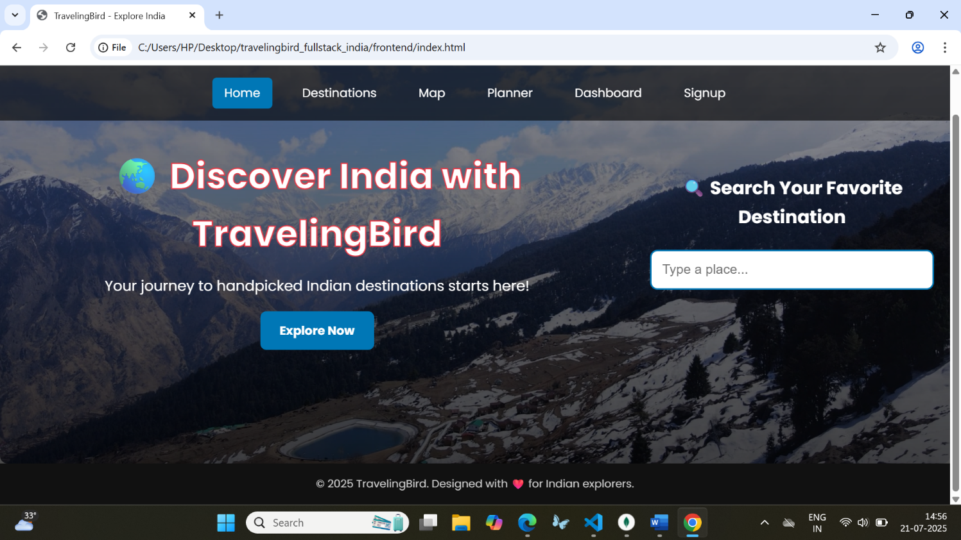

DESTINATIONS PAGE:
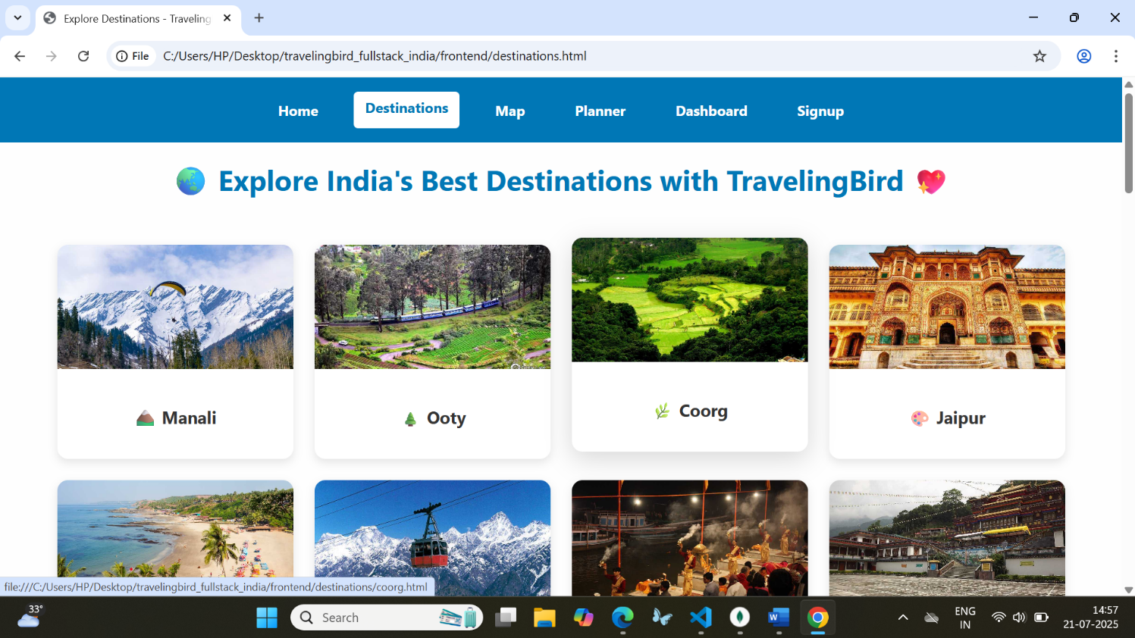

MAP PAGE:
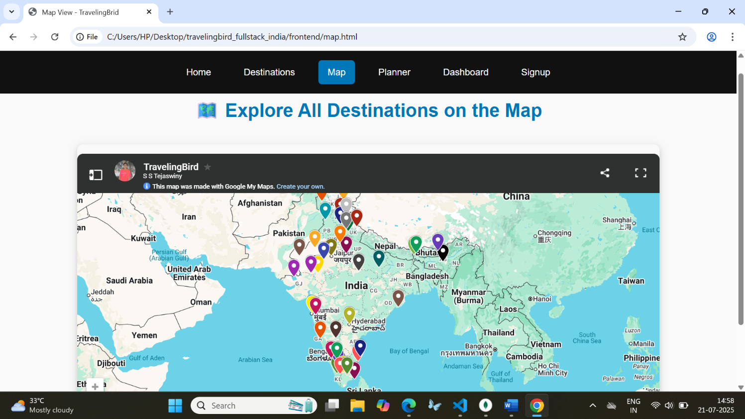

PLANNER PAGE:
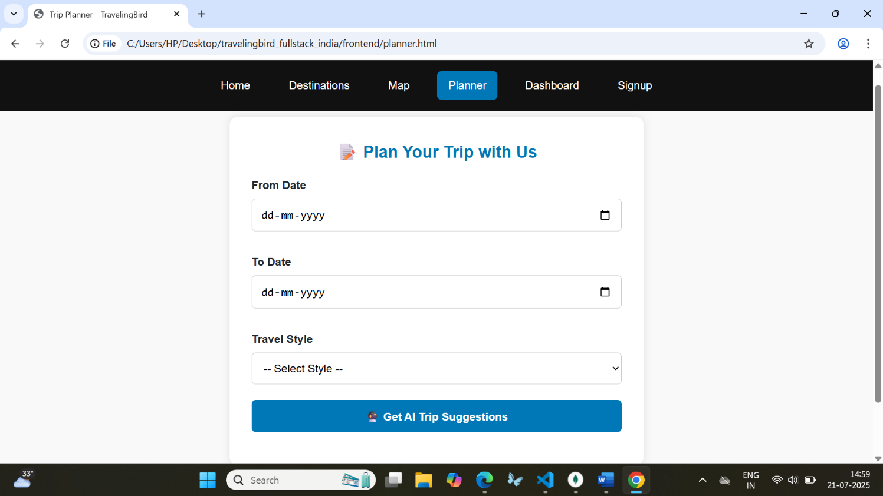

DASHBOARD PAGE:
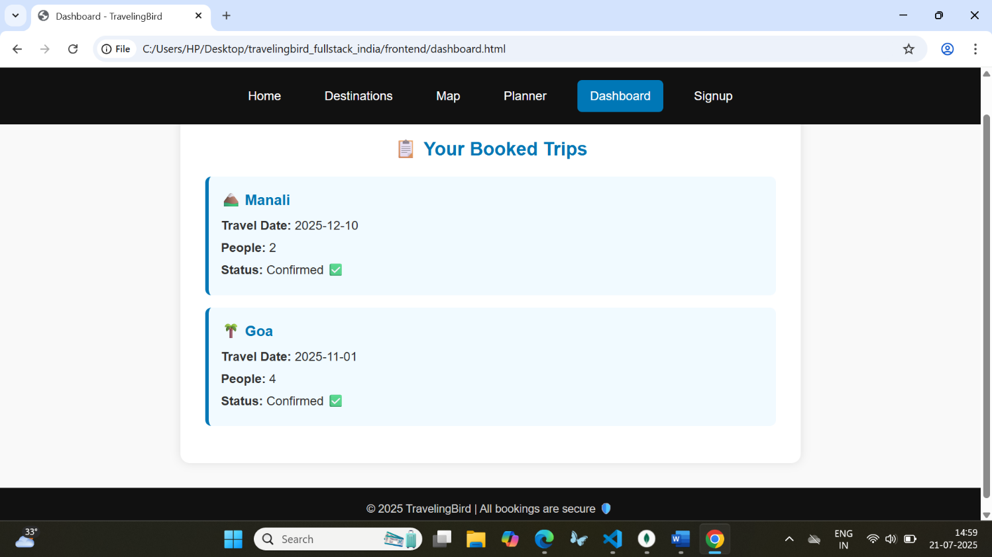

SIGNUP PAGE:
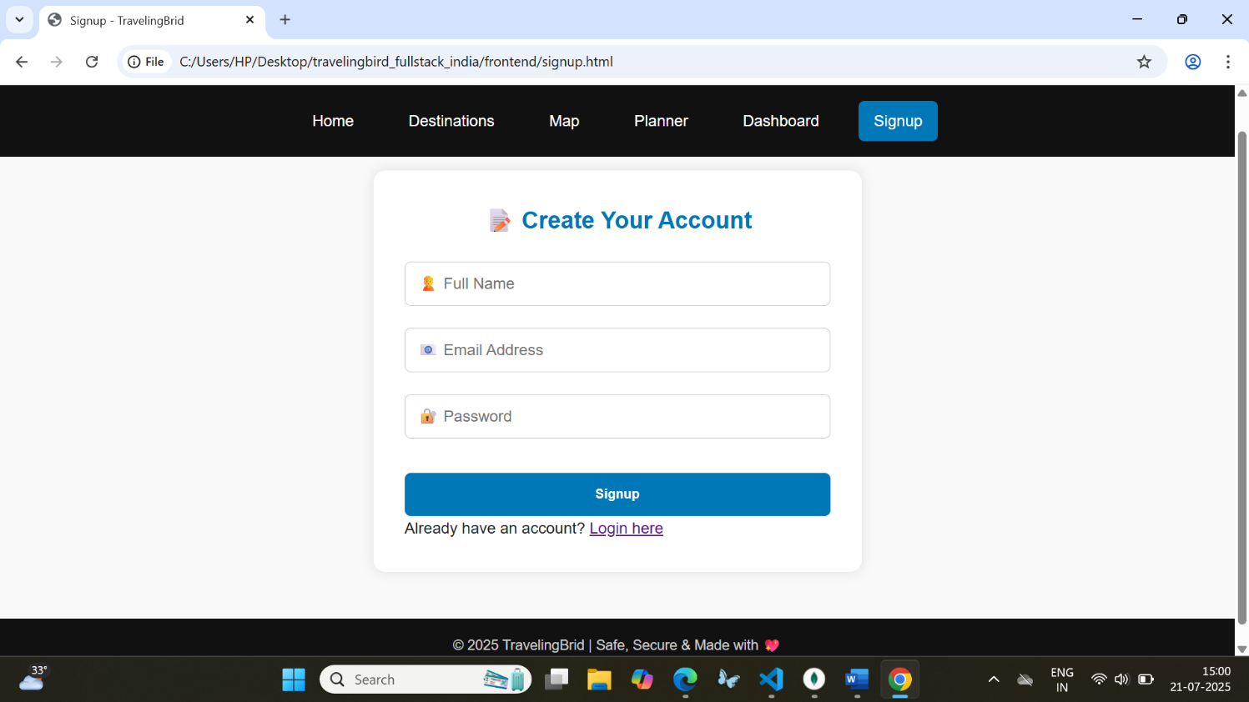

LOGIN PAGE:
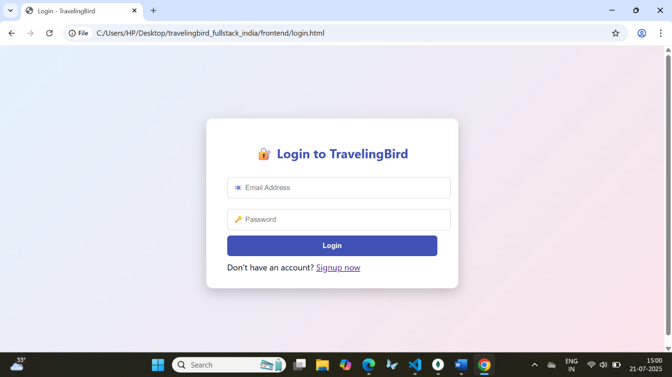

BOOKING PAGE:
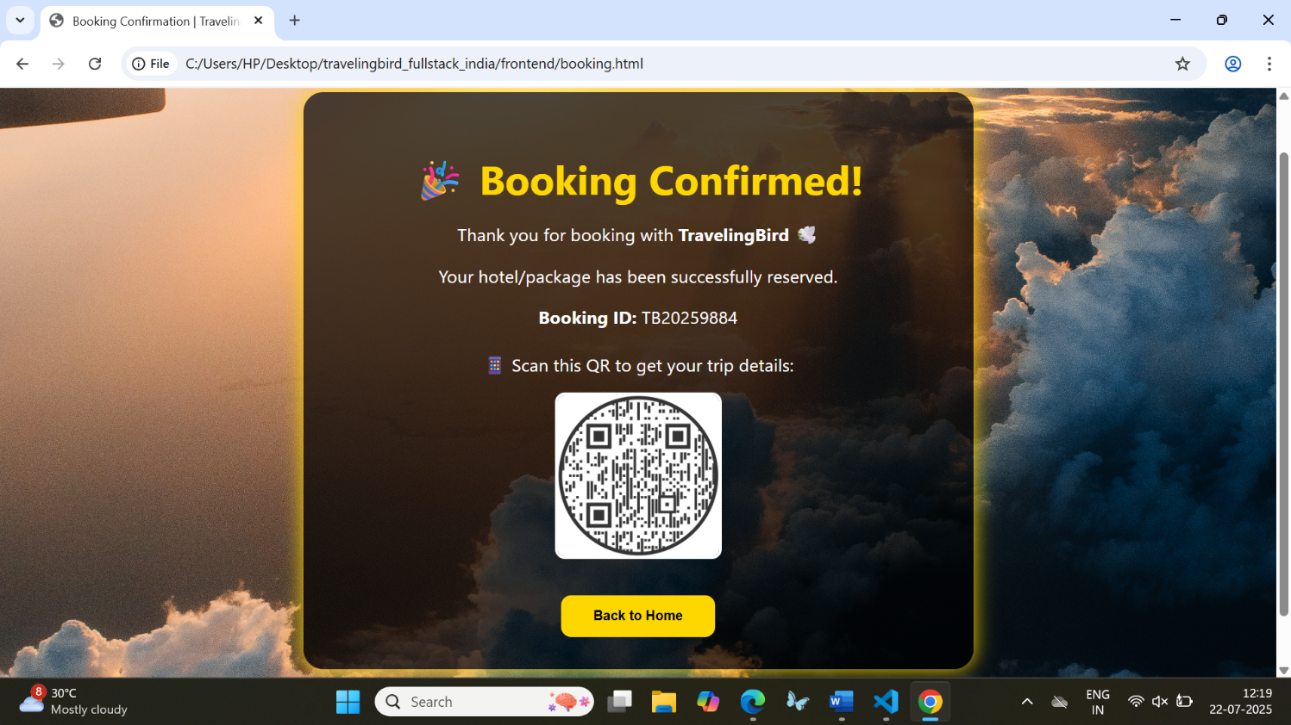

HTML CODE FOR DESTINATION [COORG] :
<!DOCTYPE html>
<html lang="en">
<head>
<meta charset="UTF-8" />
<title>Coorg - TravelingBrid</title>
<link rel="stylesheet" href="../css/style.css" />
<script src="https://checkout.razorpay.com/v1/checkout.js"></script>
<style>
body {
margin: 0;
font-family: 'Segoe UI', sans-serif;
background:
linear-gradient(rgba(255,255,255,0.9), rgba(255,255,255,0.9)),
url('https://www.toptal.com/designers/subtlepatterns/patterns/doodles.png');
background-size: 300px;
background-attachment: fixed;
}
nav {
background: #0077b6;
display: flex;
gap: 2rem;
padding: 1rem;
justify-content: center;
}
nav a {
color: white;
text-decoration: none;
font-weight: bold;
}
nav a.active {
background: white;
color: #0077b6;
padding: 0.3rem 0.7rem;
border-radius: 5px;
}
main {
max-width: 900px;
margin: auto;
padding: 2rem;
}
section {
margin-bottom: 2rem;
}
video, iframe, img {
width: 100%;
border-radius: 10px;
}
ul {
padding-left: 1.2rem;
}
.booking-form input, .booking-form button {
display: block;
width: 100%;
margin: 0.5rem 0;
padding: 0.7rem;
font-size: 1rem;
}
.booking-form button {
background: #0077b6;
color: white;
border: none;
border-radius: 5px;
cursor: pointer;
}
.booking-form button:hover {
background: #005f8e;
}
</style>
<script src="https://checkout.razorpay.com/v1/checkout.js"></script>
<script src="../js/script.js"></script>
</head>
<body>

<!-- Navigation -->
<nav>
<a href="../index.html">Home</a>
<a href="../destinations.html" class="active">Destinations</a>
<a href="../map.html">Map</a>
<a href="../planner.html">Planner</a>
<a href="../dashboard.html">Dashboard</a>
<a href="../signup.html">Login / Signup</a>
</nav>

<main>
<h1>☕ Coorg – Coffee Hills of Karnataka</h1>
<img src="../media/images/coorg.jpg" alt="Coorg Hills View" />

<section>
<h2>🌟 Best Places to Visit</h2>
<ul>
<li>☕ Coffee Plantations – walk through aromatic estates</li>
<li>💦 Abbey Falls – waterfalls in dense forest</li>
<li>🕍 Madikeri Fort – historic view & museum</li>
<li>🕉️ Talacauvery – river source at Brahmagiri Hill</li>
<li>🏞️ Raja’s Seat – valley view at sunrise</li>
</ul>
</section>
<section>
<h2>🎯 Must-Do Experiences</h2>
<ul>
<li>🌄 Stay in a plantation homestay</li>
<li>☕ Sip fresh Coorgi filter coffee</li>
<li>🧭 Trek to Tadiandamol – highest peak in Coorg</li>
<li>📸 Explore Dubare Elephant Camp</li>
</ul>
</section>

<section>
<h2>🗓️ Best Time to Visit</h2>
<p>October to March (cool & fresh) | July–Sept for monsoon waterfalls 🌧️</p>
</section>

<section>
<h2>🏨 Where to Stay</h2>
<ul>
<li>🏡 Evolve Back Coorg – luxury amidst coffee estates</li>
<li>🌿 The Tamara – scenic premium retreat</li>
<li>🛌 Heritage plantation homestays in Madikeri</li>
</ul>
</section>
<section>
<h2>🍽️ Food to Relish</h2>
<ul>
<li>🍛 Pandi Curry (spicy pork – Coorgi special)</li>
<li>🌾 Akki Roti (rice roti with chutneys)</li>
<li>🥘 Bamboo Shoot Curry</li>
</ul>
</section>
<section>
<h2>💰 Budget Range</h2>
<p>₹8,500 – ₹13,000 per person (2N/3D with homestay & experiences)</p>
</section>

<section>
<h2>🗺️ Map of Coorg</h2>
<iframe src="https://www.google.com/maps?q=coorg+karnataka&output=embed" height="300"></iframe>
</section>

<section>
<h2>🎥 Watch Coorg in Monsoon</h2>
<video controls>
<source src="../media/videos/coorg.mp4" type="video/mp4" />
</video>
</section>

<!-- Hotels & Packages Section -->
<section class="hotels-packages">
<h2>🏨 Recommended Hotels in Coorg</h2>
<div class="hotel-cards">
<div class="hotel-card">
<img src="../media/images/hotel_plantationview.jpg" alt="Plantation View Stay">
<h3>Plantation View Stay</h3>
<p>Starting at ₹2,400/night</p>
<button onclick="bookHotel('Plantation View Stay')">Book Room</button>
</div>
<div class="hotel-card">
<img src="../media/images/hotel_rainforestretreat.jpg" alt="Rainforest Retreat">
<h3>Rainforest Retreat</h3>
<p>Starting at ₹2,000/night</p>
<button onclick="bookHotel('Rainforest Retreat')">Book Room</button>
</div>
</div>

<h2>📦 Popular Packages</h2>
<div class="package-cards">
<div class="package-card">
<h3>3D/2N Nature Escape</h3>
<ul>
<li>✔️ Coffee estate stay</li>
<li>✔️ Trekking + River rafting</li>
<li>✔️ Breakfast & Cab tour</li>
</ul>
<p>₹5,400 per person</p>
<button onclick="bookPackage('Nature Escape')">Book Package</button>
</div>
<div class="package-card">
<h3>5D/4N Coorg Discovery</h3>
<ul>
<li>✔️ Luxury plantation resort</li>
<li>✔️ Abbey Falls, Dubare, Raja Seat</li>
<li>✔️ All meals + guide</li>
</ul>
<p>₹10,800 per person</p>
<button onclick="bookPackage('Coorg Discovery')">Book Package</button>
</div>
</div>
</section>

<script>
function bookHotel(name) {
alert(`✅ Hotel Booked: ${name}\nThank you for choosing TravelingBird!`);
}
function bookPackage(name) {
alert(`✅ Package Booked: ${name}\nHappy exploring with TravelingBird!`);
}
</script>

<section class="booking-form">
<h2>📝 Book This Trip</h2>
<form onsubmit="bookTrip(event)">
<input type="hidden" id="destination" value="Coorg" />
<label>Travel Date:</label>
<input type="date" id="date" required />
<label>Number of People:</label>
<input type="number" id="numPeople" min="1" required />
<button type="submit">Pay & Book</button>
</form>
</section>
</main>

<script src="../js/script.js"></script>
</body>
</html>
OUTPUT:
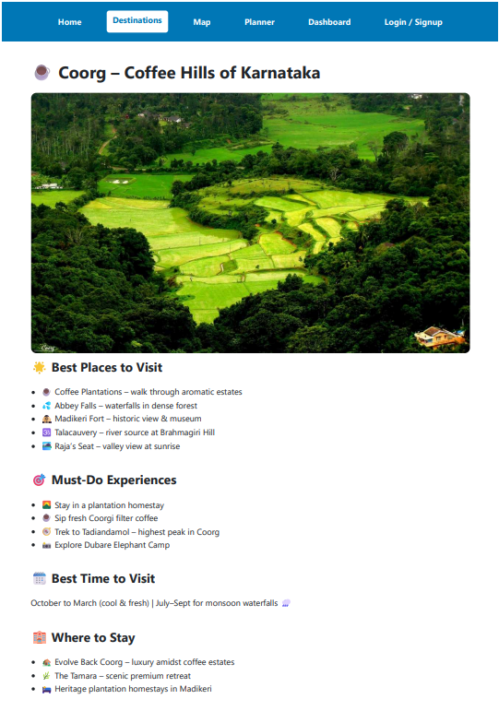
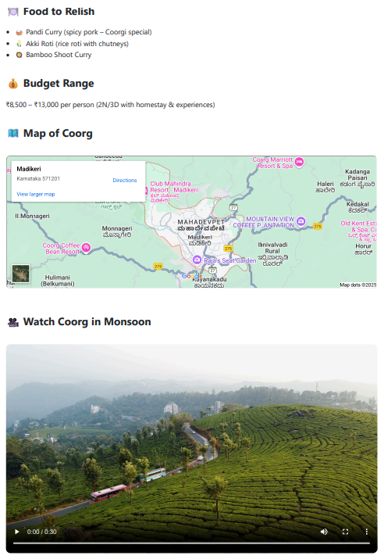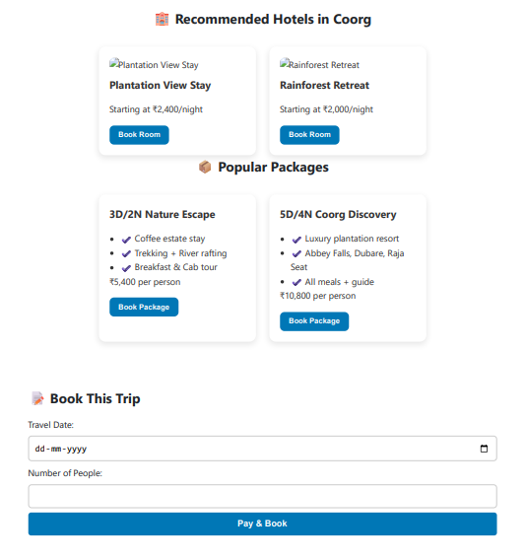

BACKEND OUTPUT:
BOOKINGS:
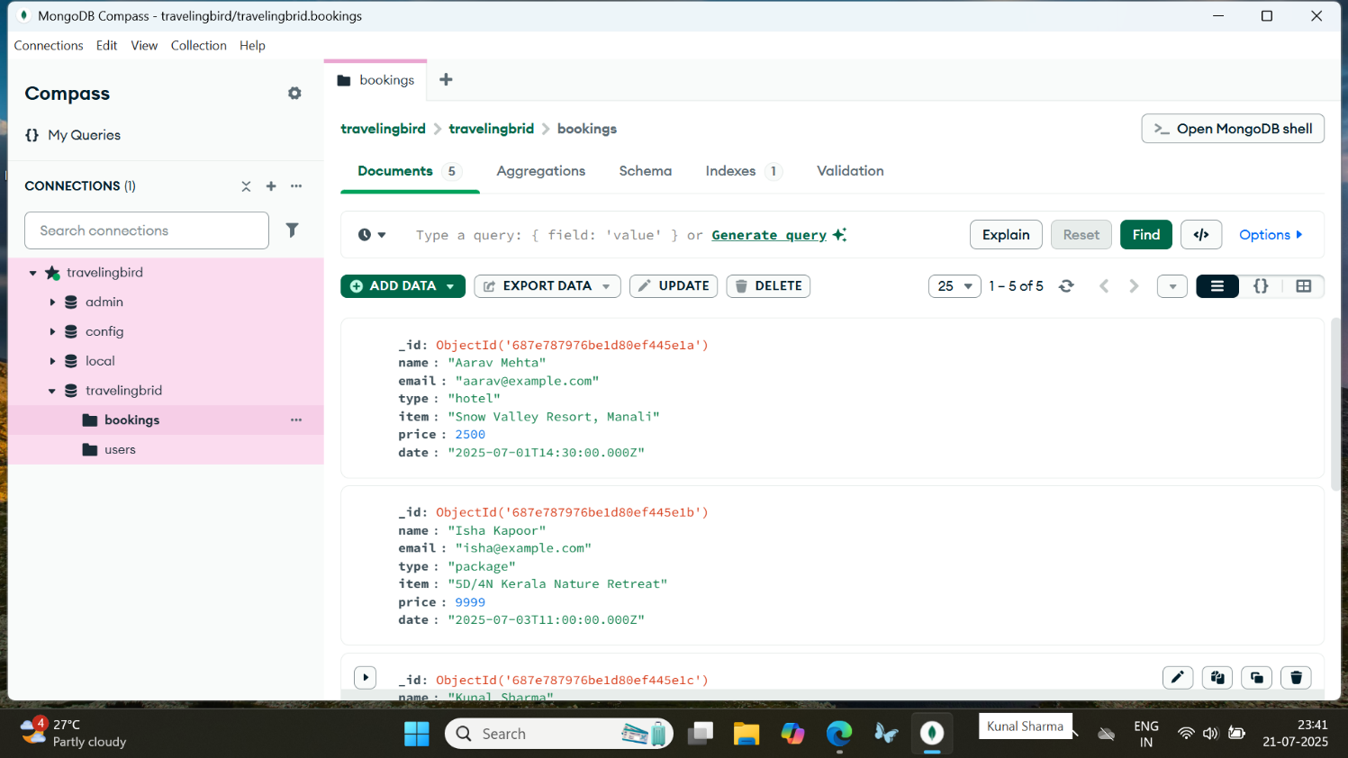

USERS:
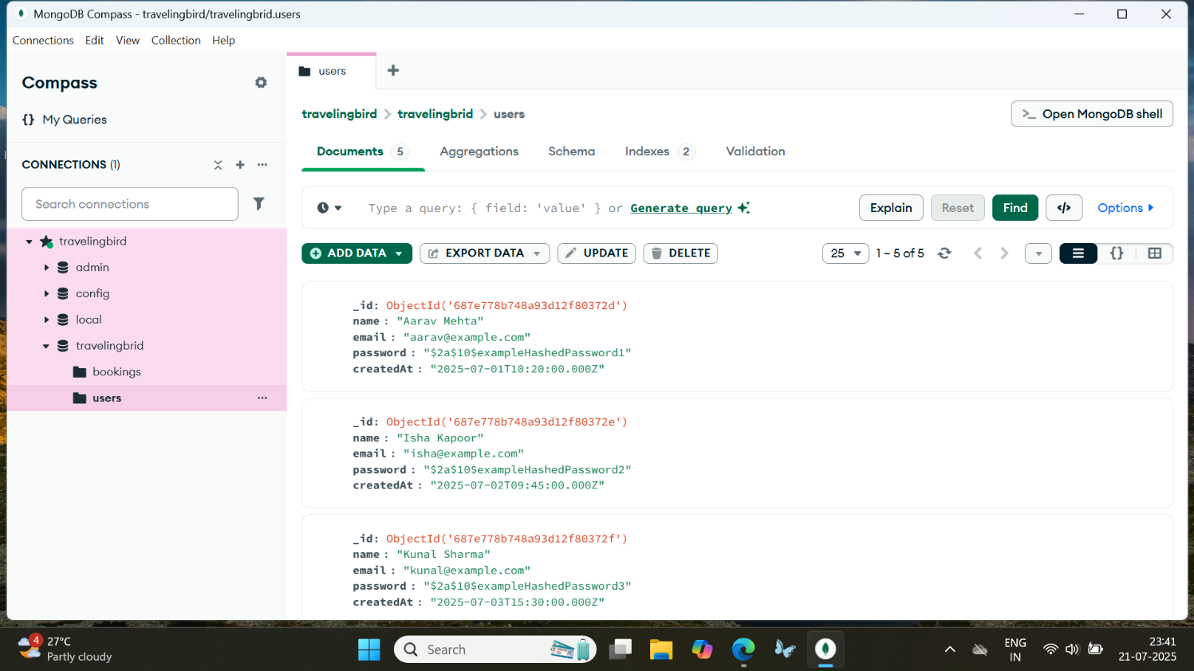

CONCLUSION

TravelingBird is a feature-rich and visually engaging web-based travel booking platform designed to simplify and enhance the experience of exploring and reserving trips across India. The project successfully integrates modern frontend and backend technologies to provide a seamless user journey — from discovering destinations to booking hotels and curated tour packages.
The platform includes:
- A beautiful video background homepage
- Over 40+ destination pages across India with immersive images, videos, and travel guides
- An intuitive search experience and AI-based trip suggestion
- Fully functional signup/login system with MongoDB storage
- A hotel and package booking system with live data and interactive dashboard
- QR code-based payment options for added professionalism
- A user-friendly dashboard to view bookings, and a responsive design for mobile devices
Technologies used:
- Frontend: HTML, CSS, JavaScript (Vanilla), animations, and responsive design
- Backend: Node.js, Express.js, MongoDB (Mongoose)
- Authentication: JWT, bcrypt
- Extras: Google Maps, Razorpay/Paytm, QR codes, admin dashboard, animated login/signup pages
Through this project, we’ve demonstrated an end-to-end travel platform that mirrors the professionalism of platforms like Holidify or MakeMyTrip — with additional personal touches, creative UI elements, and a scalable backend architecture.

REFERENCE
- Holidify – Travel Platform
Inspiration for design structure, destination layouts, and UX
🔗 https://www.holidify.com
- MakeMyTrip – Hotel & Package Booking
Referenced for booking workflows and user interface styles
🔗 https://www.makemytrip.com
- Razorpay Documentation
Used for understanding payment integration workflows
🔗 https://razorpay.com/docs/
- MongoDB Documentation
For backend database design, connection, and operations
🔗 https://www.mongodb.com/docs/
- Node.js & Express Official Docs
For creating the RESTful backend API
🔗 https://expressjs.com
🔗 https://nodejs.org
- Google Maps Platform
For embedding location-based interactive maps
🔗 https://developers.google.com/maps
- W3Schools & MDN Web Docs
Referenced for frontend HTML, CSS, and JavaScript standards
🔗 https://www.w3schools.com
🔗 https://developer.mozilla.org
- QR Code Generator APIs
Used for exploring ways to add contactless booking and payment options
🔗 https://www.qr-code-generator.com
- OpenAI ChatGPT
Assisted in code generation, planning, and step-by-step guidance for full-stack development
🔗 https://chat.openai.com

FEEDBACK
I am sincerely grateful for the opportunity to complete my internship training in Web Design at NLCIL. This experience has exceeded my expectations and significantly contributed to my professional and personal growth.
Key Skills and Experiences
- Technical Skills Developed:
  - Gained comprehensive knowledge in HTML, CSS, and JavaScript, which enabled me to build responsive and user-friendly web pages.
  - Learned the process of converting design mockups into fully functional websites.
  - Acquired experience in using web development tools and frameworks introduced during the training.
- Professional Growth:
  - Strengthened communication skills by collaborating with mentors and fellow interns on group projects.
  - Improved time management and project organization while working within deadlines.
  - Cultivated a spirit of teamwork and adaptability in a professional setting.
Memorable Highlights
- Successfully completed a capstone project, which involved designing a functional website from scratch. This experience helped me integrate all the skills I had acquired and receive constructive feedback from mentors.
- Attended insightful sessions on modern web design trends, which broadened my perspective on industry standards.
- Valued the approachable and knowledgeable mentors who provided continuous support and encouragement, making the learning process effective and enjoyable.
Closing Thoughts
This internship has been an invaluable stepping stone, equipping me with both the confidence and competence to pursue a career in web design. I am thankful to NLCIL for providing such a well-structured and supportive training environment. I am confident that the skills and knowledge gained here will guide me in future endeavours.

